Self-Reliant Literary Group, Vietnamese Humanists, 1934-1945
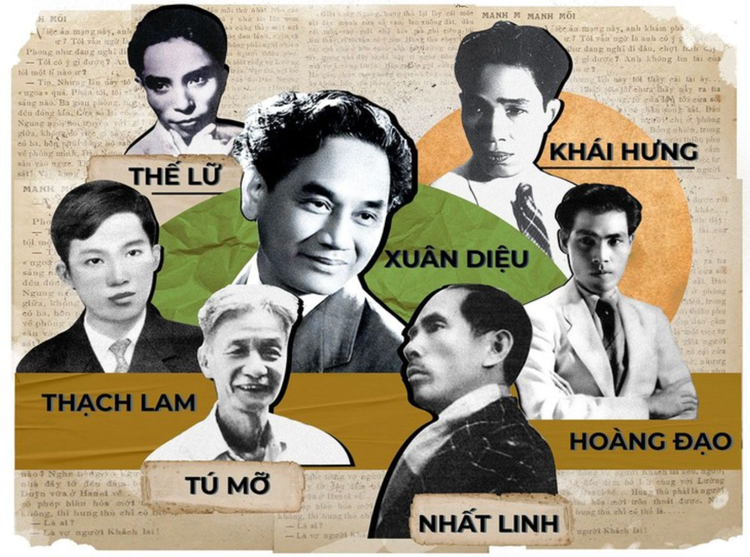
In 1934 in Hanoi, Vietnam, then under French occupation, a group of seven writers formed the “Self-Reliant Literary Group” (Tu Luc Con Doan). The term “self-reliant” was a literal description of the group’s business model. They owned their own printing press and were independent of government, capitalists, and religious groups which otherwise controlled publication. They published their own novels, short stories, poetry and plays. They were dedicated to developing literature in the language the Members of the Self-Reliant Literary Group people actually spoke, using the new Vietnamese phonetic alphabet in place of Chinese characters. Purely as a business, their success was impressive. Between 1934 and 1945 the group published 160 book titles, including 41 for children, and sold roughly 450,000 copies total. This was in a language which about a million people could read. They also published two magazines with circulations in the thousands.
But the Self-Reliant Group had even greater ambitions. They wanted to develop a new Vietnamese culture and society, one which used reason and science to transform society. They believed that a new, rational, democratic Vietnam could easily resist domination by foreigners, such as the traditional enemy, China, or the new oppressor, France.
A prominent vehicle for expression of the Group’s ideas was their magazine Mores (Phong Hoa). (Mores is the English spelling of the French world for “customs”.) They announced their philosophy in 1934 in the first issue of the magazine.
[Mores]
1) On our own strength, produce literary works of value, not just translate works from foreign countries just because they have literary worth. This is to enrich the literary corpus of the nation.
2) Produce or translate only works that reflect on society, for the purpose of helping people and society improve by the day.
3) Follow populism (bình dân), produce only works about the common people, and encourage others to love populism.
4) Use a simple literary method—easy to understand, few Chinese characters—a literary method that truly embodies the Annamese character.
5) See everything as new, young, life-affirming, with a fighting spirit and a belief in progress.
6) Praise the beauty of our homeland as it reflects the common people, which in turn encourages others to love their country in a populist way. Avoid any sense of elitism and aristocracy.
7) Place the utmost importance upon individual freedom .
8) Persuade others that Confucianism is no longer with the times.
9) Bring the scientific methods of the West into Annamese literature.
10) To follow one of the above nine things is acceptable, so long as one does not violate any of the others.
(Notes on translation. This text and others below are from the book On Our Own Strength: The Self-Reliant Literary Group and Cosmopolitan Nationalism in Late Colonial Vietnam , by Martina Thucnhi Nguyen. Nguyen translates the Vietnamese word bình dân as “populism”. This can be misleading because “populism” in English can connote ignorant irrationality, the opposite of the Group’s philosophy. A literal translation is “of the people ” This article has enough quotes from the Group’s writings that readers can decide for themselves a good description. I would call it “democratic humanism.” Many writers of this period used the words “Annamese” and “Vietnamese” interchangeably. When the group denounced “Confucianism” they were not discussing the details of Confucius’ thought, but denouncing traditionalism, particularly the worship of all things old and Chinese.)
The Group believed that the people of Vietnam should look out to the world beyond their traditions:
[Mores] These days, people see and travel a lot. We need to have wide knowledge. Events in places thousands of miles away also affect us, and as we well know, their effects can be dangerous. But they are especially dangerous for those who sit around gazing at their navels, those who never leave the green bamboo hedges of their villages.
Humor
The Group believed that humor was both a good way to communicate and important safeguard against fanaticism.
[Mores] Why don’t we laugh wholeheartedly to destroy the malaise of yesteryear, so that our society will have a strong active spirit!
[Mores] Mores doesn’t want to teach anyone. In the end, we only hope that in the humorous words printed on these 16 pages, our readers will find things they find useful. We think that no matter how necessary or beneficial something is, it would be hard for readers to welcome it without humor. And when readers don’t welcome it, then there is no hope of teaching anyone anything. Therefore, we see our newspaper as a comic play: the public reads it and laughs. If they see a lesson hidden in there, that’s even better.
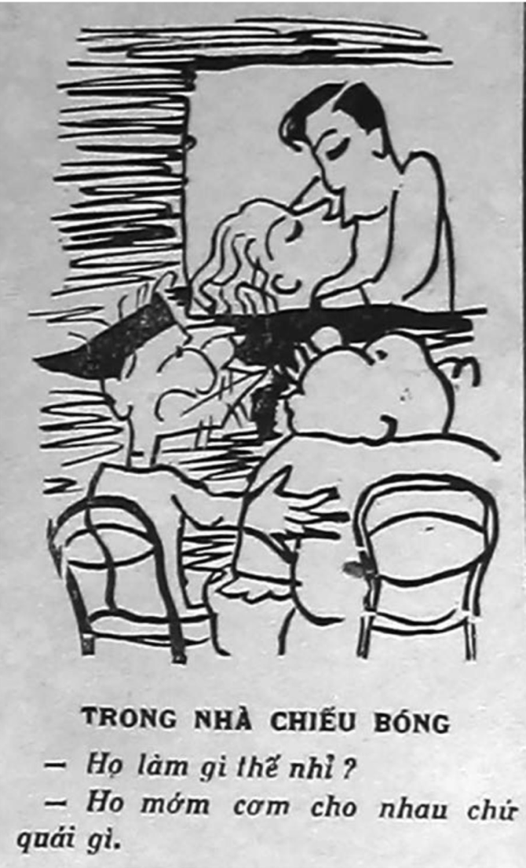
[Mores] Education in the past has taken two parallel roads. The first road wants to take us to a perfect ideology according to the ideals of a number of people we revere. Another road takes us around and around humanity, so that we have direct contact with both the worthwhile and lamentable aspects of mankind, then use our intellect to recognize the good and copy it, the bad to avoid it. We only take our readers on the second road and even though we crack a smile at the lamentable things, it is only because we are cheerfully discussing it with our readers. We are not trying to teach, and we don’t want to!
For example, on the front page of the first issue of the magazine. They describe how they consulted a leading astrology authority on the Sept. 22 start date for their magazine and found, “September 22: An inauspicious day (ngày tứ ly). One should not do anything today.” But since the astrology text had no discussion of magazines particularly, “Although our launch date fell on an unlucky day, we still had to take the risk.”
A popular feature of Mores was cartoons. They often joked about the difficulties traditional Vietnamese had with unfamiliar cultures. For example, in the cartoon of two traditional Vietnamese viewing a French movie, one asks, “What are they doing?” The older, who assumes that the couple are engaged in the rural practice of premastication, replies condescendingly to his sidekick, “They are feeding each other rice, that’s what.”

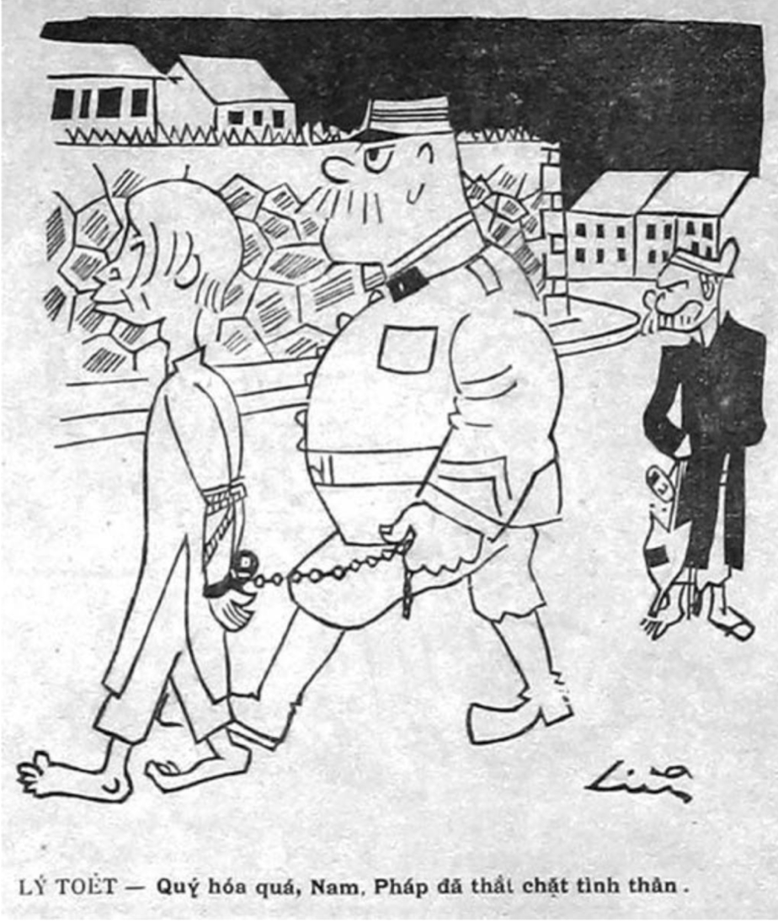
Humor can, of course, express anger. In a cartoon showing a French policeman arresting a Vietnamese, the stereotypical rural Vietnamese sarcastically comments, “How precious, Vietnam and France and tightly bound in spirit”
Sarcasm could be used against rival publications. For example, Mores praised the sleep-inducing quality of a conservative rival:
[Mores] “Take an issue of Southern Wind, choosing an issue that specifically discusses ‘national soul and national essence,’ remove the translated Tang poetry by Tùng Vân, and mix with colonialism. Boil into a paste and form into cakes … whenever one needs to sleep, eat one cake and see results instantly.”
Fashion
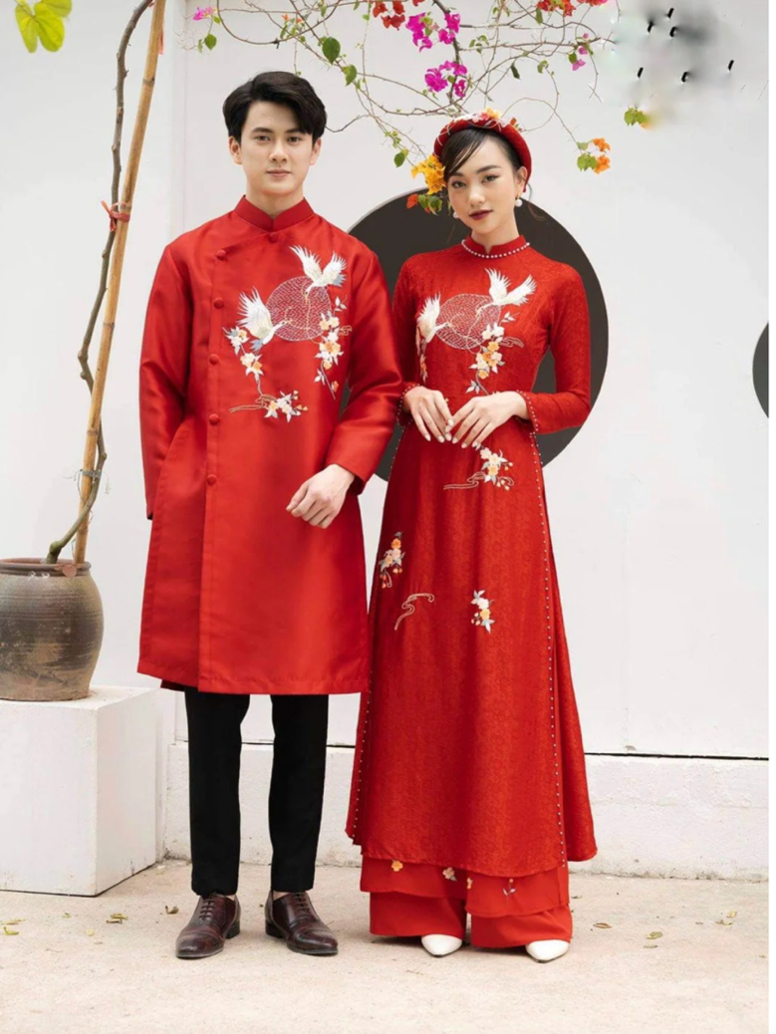
The Self-Reliant Group had a strong belief in the importance of material reality, as opposed to abstractions like God, tradition, or any rigid ideology. A big part of day-to-day material life is the clothing people wear. The Group felt that people in Vietnam were trying too hard to emulate Chinese styles which were, in many cases, impractical in China, but were particularly inappropriate in the hot climate of Vietnam. The main clothing designer in the Group, who used the penname “Lemur”, designed an outfit which, while resembling traditional clothing, was practical in a hot climate, combining comfortable baggy pants with a long tunic of light fabric. It was also important to look good. The result was the ao dai. Lemur explained:
[Lemur in Mores] “Except for a few that feign morality or go against the common grain, everyone else—no matter man or woman—should be honest and ask, ‘who does not like to look good?’ The desire to be beautiful is a collective trait and not a bad one, so we need not hide it … Materialism is intimately related to the soul, and the soul is what clearly differentiates between humans and animals. Humans are different from animals in their intellect and because they wear clothing.” Contemporary ad for wedding Ao Dais
Lemur wanted the ao dai to be practical, attractive and a symbol of Vietnamese culture. As a fashion concept, the ao dai was a spectacular success. Although it can be worn by men, and often is at weddings, it is much more often worn by women, of all backgrounds and politics.
Architecture
The Group’s concern about material life included architecture, particularly the dwellings in which people lived. The Group believed that while resources were limited, intelligent planning could make better low-cost housing than that in which most urban Vietnamese lived, particularly with regard to sanitation. The Group was particularly disgusted that communities were spending money on religious shrines when people lived in unsanitary conditions. In 1938 the Self-Reliant Group’s leader Nhat Linh created a new, much larger organization, the League of Light, to promote better housing.
[Nhat Linh] “[The Vietnamese] pay too much attention to spiritual matters…. We must now make them focus on the material.”
[Nhat Linh] Damp, low-ceilinged, and barren, the houses in Vietnam are a pile of mud mixed with rubbish. They are disgusting. Puddles of water full of scum and trash make the ground perpetually damp and muddy. In hot weather, they give off a heavy odor. In winter, the moisture condenses into streams of smelly water. People and animals live and eat together, sharing the same dark tight place.

[Nhat Linh] A clean, sanitary, bright house, two nutritious meals a day, warm clothing. Those are the peasant’s first needs in life. Only when the peasantry adopt a rational, material view they can turn their sights on the pressing issues of rural livelihood—the expansion of craft industries, formation of rural work associations. They would learn how to work systematically and be industrious and thrifty, all which are necessary to better their well-being. They would be able to help and understand the government on matters of livelihood. League of Light flag
The League got off to a good start, building one model development. The colonial government was sympathetic with one senior French official reasoning, “if everyone had a house and a small garden then there will be no more communists.”
But the League’s projects were soon overwhelmed by the event of World War II, during which the Self-Reliant Group was inevitably drawn into more explicit politics.
Politics
The Self-Reliant Group were democratic socialists. They strongly believed in individual freedom, science, and community. They were opposed to what they considered oppressive ideologies, including traditional religion and Communism. However, they were generally willing to compromise, including with Communists. They worried that Communism would appeal to poor Vietnamese.
[Group] People can have whatever opinion they like about communism, but we must admit that the current situation in society, politics and economics is not at the place where we could experiment with that ideology. The majority of people are still undeveloped in their intellect and still ignorant about many things. If we directly appeal to and mobilize them, then things could easily fall into demagoguery.

The victory of Socialists led by Léon Blum in the 1936 French elections led to a paradox. The Vietnamese were oppressed by a colonial power which was, in principle, opposed to colonialism and, indeed, largely agreed with the Group’s philosophy.
[These Days] We should not go overboard with the celebrations. The Socialist Party is one thing, but a socialist elected government is something different. Mr. Léon Blum the Socialist Party leader is not going to be the same as Mr. Léon Blum, President of the Council. The only certain thing is that we must rely on ourselves.
The Self-Reliant Literary Group did not survive World War II. Japan occupied Vietnam, although Vichy France administered it for most of the war. In the immediate aftermath of the war Communist leader Ho Chi Minh formed a coalition government for the Democratic Republic of Vietnam. Self-Reliant Group leader Nhat Linh was foreign minister in Ho’s coalition government. In December 1946 open fighting broke out between Ho’s government and the French who were attempting to reestablish colonial rule. Ho’s agents arrested or assassinated non-Communist Vietnamese nationalists including associates of the Self-Reliant Literary Group such as fashion designer Lemur. Nhat Linh fled, realizing that being foreign minister was no protection against assassination. He ended up in South Vietnam where, extremely unhappy with the Diem government, he committed suicide in 1963. A few members of the Self-Reliant Group joined the Communists and lived to old age.
The poet, The Lu, who joined the Communists, wrote “Moments that pain the heart, You go your way, I go mine. Our mutual commitment has run its course.”
The Self-Reliant Literary Group is not forgotten. Many Vietnamese still remember their philosophy:
[Group] From when we began our newspapers, we hoped that people will gradually transform themselves; that hope will never fade. Our idea is to transform society peacefully within the confines of the law. We want us to save ourselves, to figure out what we need ourselves, and satisfy these needs ourselves.
We will gradually act on all fronts to raise the standards of the peasantry. They need to become self-aware and know how to champion their own rights; only then will they progress to a just life and an equal society. They will have the freedom to represent themselves, or choose suitable people who will advocate for them … There has never been a transformative event that did not come from gradual historical process (even that of France in the past or recently in Russia). Fruit only fall from trees when ripe and history is no different. Our responsibility is to find a way to ripen the fruit on the tree, to raise people’s intellectual capacity to enlighten them. Ideology must by supported by reality. We cannot express all of our ideas here. As journalists, we can only do our best to support our ideology of populism. Little is better than nothing at all.

