Humanism in 19th Century Japan
Last month we talked about the amazing success of the Balmis expedition in spreading smallpox vaccination in the Spanish Empire of the early 1800s. The expedition vaccinated people from Argentina to Mexico to the Philippines and on to China. Bringing vaccination to Japan was harder. From 1603 to 1868, the period of the Tokugawa shoguns, the Japanese government strictly isolated Japan from almost all contact with the outside world. A few Japanese doctors worked against this isolation to bring outside medical ideas, notably smallpox vaccination, into Japan. Conservatives were afraid that admitting even something as obviously desirable as vaccination could lead to a larger embrace of rationality and science in place of tradition. They were right.

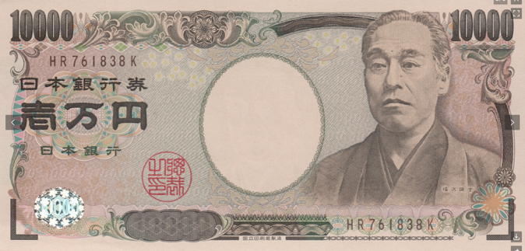
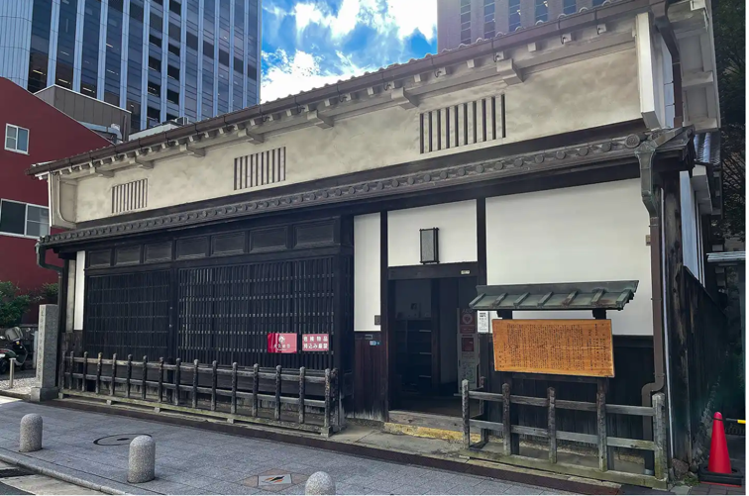
Ogata Koan (1810-1863) was a Japanese physician who founded the Tekijuku medical school in Osaka in 1838. Ogata had no use for traditional religion. He believed the purpose of human life was to benefit other humans. Ogata taught that all humans were fundamentally equal, a fact which could be scientifically proven by medical research. In 1849, Ogata set up the first vaccination clinic in Osaka, vaccinating large numbers against smallpox. At Tekijuku students were allowed access to a small number of Tekijuku today, museum in downtown Osaka medical textbooks written in Dutch. (The small number of Dutch in Nagasaki were the only foreigners allowed in Japan.). Very few people, except medical students, could actually read Dutch, so the school was able to keep a few Dutch books on broader topics, science generally, but also some political thinking. In 1853 the US Perry expedition forced the Japanese government to allow trade between the US and Japan, ending the Tokugawa isolation. In response, many Japanese thought it important to learn the technical skills of the foreigners so that Japan could avoid foreign oppression. In 1862 Ogata was invited to a senior government position in Tokyo. Ogata died of tuberculosis in 1863, but many of his students played important roles in the development of rational science and engineering in Japan.

His most influential student was Fukuzawa Yukichi (1835-1901). In 1871 Fukuzawa published An Encouragement of Learning, one of the important books in Japanese history. Reportedly, 3.5 million copies were printed in a country with maybe 7 million literate people. The most famous line in the Fukuzawa Yukichi on current currency book is its first. “Heaven does not create one person above or below another.” Traditional caste distinctions between samurai and commoners are toxic bullshit. All races are the equal. (The Japanese word “Ten” is conventionally translated as “Heaven”. It could also be translated as “Nature”. It means the order of the universe, not “Heaven” in a Christian sense.) All the quotes in this reading are from that book.

The book begins:

Fukuzawa: "It is said that 'Heaven does not create one person above or below another.'" Thus, when Heaven gives birth to people, all people are equal in position, without distinction of high or low, noble or mean, at birth, and using the function of the body and mind, which are the spirits among all things, they are provided with all things between Heaven and Earth, thereby fulfilling the needs of clothing, food, and shelter, and are given to spend this life freely, without interfering with each other, and in comfort. However, looking widely at this human world now, there are wise people and foolish people, the poor and the rich, the noble and the humble, and their appearance seems to differ like clouds and mud. The reason for this is quite clear. In the "Jitsugo-kyō," it is said, "If people do not learn, they have no wisdom, and those who have no wisdom are foolish." Therefore, the difference between the wise and the foolish is made by whether they learn or not.
Fukuzawa believed that everyone was born equal, but all people could improve themselves through education.
Fukuzawa: The fact that commoners have already been allowed to use surnames and ride horses is a beautiful event unprecedented since the beginning of time, and it can be said that the foundation for equalizing the status of the four classes of samurai, farmers, artisans, and merchants has been established here.
Moreover, now that the principle of equality among the four classes has been established, everyone should be at ease and act fully in accordance with the principles of Heaven, but people of all walks of life have their respective statuses, and they must have the appropriate talents and virtues according to their status. In order to equip oneself with talents and virtues, one must understand the principles of things. In order to understand the principles of things, one must learn to read and write. This is the urgent need for learning.
This emphasis on learning is classic Confucianism. Fukuzawa’s difference with the traditional Confucianism of his time is that traditionalists thought “education” meant memorizing ancient Chinese poetry. Fukuzawa thought people should learn about the real world.
The use of Chinese characters (called Kanji in Japanese) to write the Japanese language has long been controversial in Japan. One has to learn thousands of them to be able to read. The Koreans replaced Chinese characters with a phonetic alphabet (Hangul) in the 1400s. Fukuzawa thought that Japan should move in that direction.
Fukuzawa: Learning does not mean knowing difficult characters, reading incomprehensible ancient texts, enjoying waka poetry, composing poems, and other impractical literature in the world. These literary arts naturally delight people's hearts and are quite elegant, but they should not be revered and valued as Confucian scholars and Japanese scholars have claimed since ancient times. Among Confucian scholars of the past, few were skilled in household management, and among merchants who excelled in waka poetry, few were skilled in business. Because of this, some concerned merchants and farmers, upon seeing their children devoting themselves to learning, worry in their parental hearts that they will soon squander their family fortune. It is not unreasonable. After all, it is proof that their learning is far from practical and does not meet the needs of daily life. Therefore, putting aside such impractical learning for now, what should be devoted to is practical learning close to the common daily use of human beings. For example, learning the forty-seven kana characters, the wording of letters, how to keep accounts, practicing the abacus, handling scales, and so on, and there are many more items to learn as one progresses further. Geography is a guide to the terrain of not only Japan but also all the countries of the world. Science is the study of observing the nature of all things in heaven and earth and understanding their workings. History is a detailed chronicle that investigates the state of all countries, past and present. Economics describes the household management of individuals and families to that of the entire country. Ethics is a description of the natural principles of cultivating one's conduct, interacting with others, and living in this world.
Fukuzawa believed in freedom, but strongly objected to the “Geisha House” culture in which wealthy men would spend money on alcohol and expensive prostitutes. He felt this culture was inconsistent with women’s equality.
Fukuzawa: Although people are naturally born unfettered and unbound, and a full-fledged man is a man and a full-fledged woman is a woman, free and unrestrained, if one only advocates for freedom and does not know one's place, one often falls into selfishness and debauchery. In other words, that place is based on the principles of Heaven, follows human emotions, and achieves one's individual freedom without hindering others. The boundary between freedom and selfishness lies in whether or not it hinders others. For example, if one spends one's own money, it may seem that one can freely indulge in alcohol and debauchery to the fullest, but this is not the case at all. The debauchery of one person becomes an example for many, eventually disrupting the morals of society and hindering the education of others. Therefore, even if the money spent belongs to that person, the sin cannot be forgiven.
Fukuzawa did not believe in any traditional religion. Much of his writing attacked Buddhism, which he thought made people too fatalistic. He believed Christianity was even worse than Buddhism, mostly because Christianity motivated Christians to kill other Christians. He thought the European wars of the Reformation and institutions like the Spanish Inquisition illustrated the insanity of Christianity. In the passage below he is writing for a Buddhist audience and takes examples from Buddhism. He uses medical examples, reflecting his youth at Ogata’s atheistic medical school. (Fudo Myoo is a popular Buddhist god.)
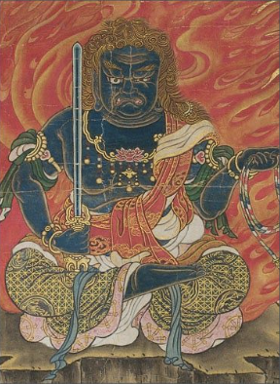
Fukuzawa: In the world of belief, there are many falsehoods; in the world of doubt, there are many truths. Try and see, the ignorant people of the world believe in what others say, believe in what others write, believe in novels, believe in rumors, believe in gods and buddhas, believe in divination, believe in the words of masseurs for their parents' serious illnesses and use herbs and tree bark, believe in the instructions of feng shui masters for their daughters' marriage proposals and lose good husbands, call for Buddhist chants instead of inviting doctors for fevers because they believe in Amitabha Buddha. Dying from a seven-day fast is because they believe in Fudō Myōō. If we ask about the abundance or scarcity of truth practiced among these people, we cannot answer that it is abundant. If truth is scarce, falsehood must be abundant. Indeed, although these people believe in things, their belief is in falsehood. Therefore, I say, "In the world of belief, there are many falsehoods." Fudo Myoo
Seeking the truth of things amidst different opinions and arguments is like sailing a boat against the wind. The boat's path turns right and left, fighting against waves and wind, and even after passing through hundreds of miles of sea, if we calculate the direct path, the progress is only three or five miles. Although there are often conveniences of favorable winds in sea voyages, there are never such things in human affairs. The path of human progress reaching truth is only through the method of intervals amidst different opinions and arguments. And the source of these opinions and arguments lies in and exists at the point of doubt. This is indeed what is meant by "In the world of doubt, there are many truths."
One respect in which Fukuzawa’s writing differs from the humanism of Voltaire, Aristotle and Confucius is its view of nationalism. Aristotle and Confucius thought about politics a _lot_. Both thought government was a device to serve humanity. Nation-states per se had no independent value. Fukuzawa sees things differently. He clearly believes all people are equal. Cultures should freely learn from one another. Yet he concludes that Japanese should be willing to die for their country’s “prestige”. This combination of rationalism and nationalism, which I find hard to understand, has had a lot of impact in Japanese history.
Fukuzawa: Also, the matter of freedom and independence applies not only to an individual but also to a country. Our Japan is an island nation located in the east of the Asian continent, and since ancient times, it has not established relations with foreign countries and has been self-sufficient with its own domestic products for clothing and food, never thinking of any shortages. However, since the arrival of Americans in the Kaei era [Perry in 1853], foreign trade began, leading to the current situation. Even after the opening of ports, there were various debates, and some vehemently advocated for the expulsion of foreigners and the closing of the country, but their perspective was extremely narrow, like "a frog in a well" as the saying goes, and their arguments were not worth considering. Japan and Western countries exist in the same space between heaven and earth, illuminated by the same sun, gazing at the same moon, sharing the same seas and air, and are peoples with the same emotions. Therefore, we should give what we have in excess to them, take from them what they have in excess, mutually teach and learn from each other, without shame or pride, mutually achieve convenience, mutually pray for each other's happiness, establish mutual relations in accordance with the principles of nature and the way of humanity, bow down to the black slaves of Africa for the sake of reason, and not fear the warships of Britain and America for the sake of the way. If there is any disgrace to the country, all the people of Japan should be willing to give their lives without exception to uphold the country's prestige. This is what should be called the freedom and independence of a nation.
Fukuzawa died in 1901. He was, and is, much honored. His teacher, Ogata Koan, is also regarded as a national hero.

